Apply filters to SQL queries

Project description
I recently discovered a potential security incident that occurred during non-working hours, and therefore my job as a Security Analyst is to access databases using SQL language, do the following:

Retrieve after hours failed login attempts
With this code we can find out when there have been login attempts outside of business hours that have failed.
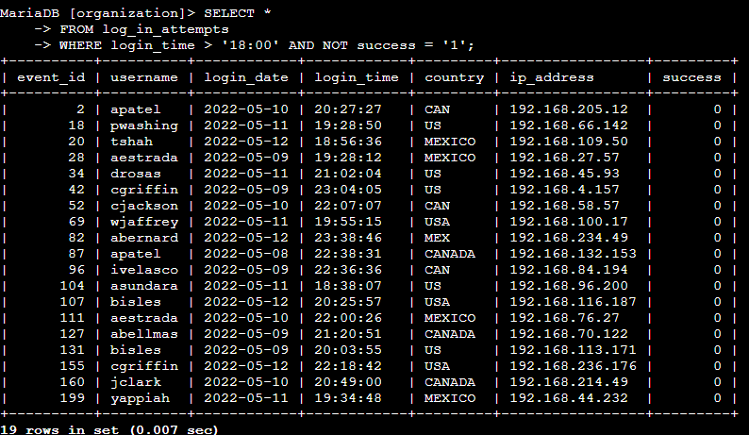
Here, my query works in such a way that I request all possible data, in the first line, from a specific page, which is indicated in the second, but here, my most important task is to filter the data so that it is correct for the current task, this is exactly I'm demonstrating here.
Here, we can see that the column called "login_time" is adjusted for non-working hours, which removes all the results that we do not need, and it will also show all unsuccessful attempts, since the command "NOT success = '1'" indicates that in the response We were not shown all the attempts that were successful.

Retrieve login attempts on specific dates
Using this code we reference specific dates on which the incident is known to have occurred, we ask the database to provide us with information about after-hours login attempts to find out more information about the incident.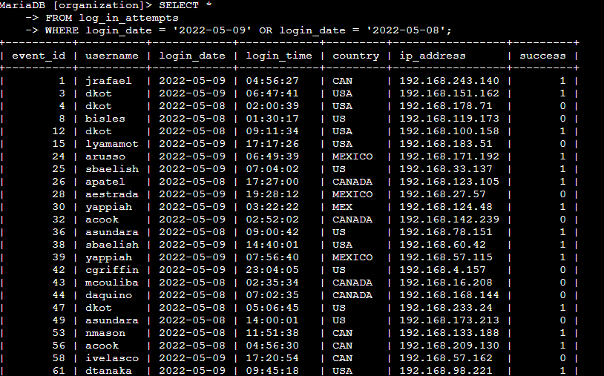
Here we can see how in the third line of code I use filtering on the "login_date" column, since the incident took place at a certain designated time, we are interested in the specific dates that I specified in the third line.

Retrieve login attempts outside of Mexico
The team recorded that the suspicious activity in the company was definitely not from Mexico, so we will exclude this country from the filter of the data we are interested in:
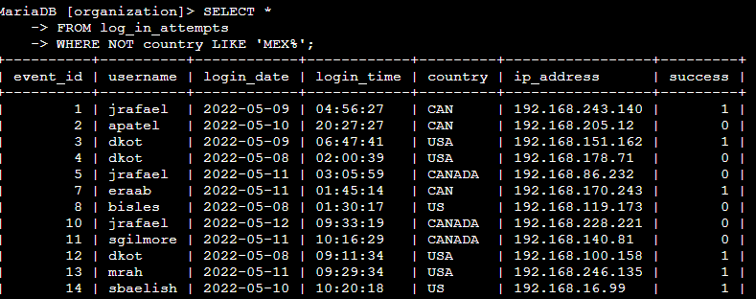
Here, in the third line, we can see that I used the "NOT" command to filter and also used the "LIKE" command to filter similar values, which can be designated for example as "MEX", which also means that suspicious traffic was detected not from there.

Retrieve employees in Marketing
Since my team wants to analyze all the data in the marketing office of the east office:
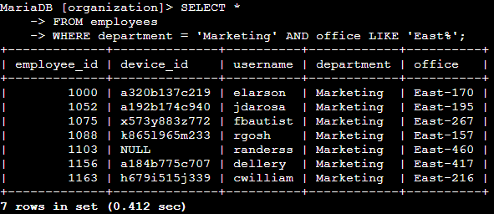
Here, in the third line we can see that we will filter only employees, only from the department (department value) 'Marketing', and we will also filter only from the eastern building, which is the value "East%", the percent sign here means that we It doesn’t matter what office number it is.

Retrieve employees in Finance or Sales
Our team is faced with the task of updating security systems in the Sales and Finance department.
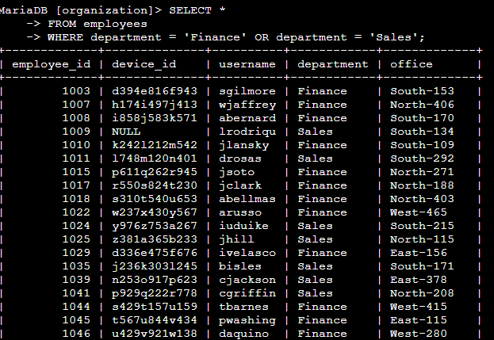

After completing the task, I selected all the data using the “SELECT *” command from the “employees” database, after which I filtered the data in such a way that only those devices that are in the"Finance" and "Sales " department were displayed there, which is what we need , we can see this in the third line. WHERE is responsible for filtering, "department = 'Finance' OR department = 'Sales" means that we are only interested in those systems that are located in the finance and sales department, the display of which we see in the image.

Retrieve all employees not in IT
The next task, our team was tasked with updating all systems except the IT department, for this we must identify all systems that are not IT systems.
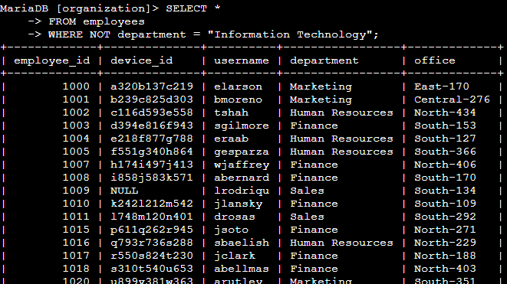
Here we can see that with the help of the first two lines of code, we access the database we are interested in, after which in the third line we set up filtering so that all systems except IT are displayed to us, the NOT command in this case is responsible for excluding all non-IT systems. systems of interest to us,
and "department = 'Information Technology" demonstrates systems from which particular department we are not interested in.

Summary
Thus, we can see what a primary role filtering plays in my work, and how flexibly and efficiently these commands can be used to perform important tasks.

